Name: Astha Arpit Bhatt

Enroll: 196140316006

ITA Sem:6

**MINI-PROJECT**

Aim: Develop Student Registration form with the use of Java-swing and store these data on MySQL database.Show Button shows all detail of student table.

**CODE:**

package miniproject1;

import javax.swing.*;

import java.awt.*;

import java.awt.event.*;

import java.sql.*;

public class MiniProject1 extends JFrame implements ActionListener{

JTextField t1,t2,t3,t4;

JTextArea ta1,ta2;

JLabel l1,l2,l3,l4,l5,l6,l7,l8,msg;

JRadioButton it,cmp,civil,mechanical;

JCheckBox first,sec,third,fourth,fifth,sixth;

JComboBox term;

JButton save,show;

JTextArea screen;

public void regis(){

setTitle("Registration Form");

setSize(900,700);

Container c = getContentPane();

c.setLayout(null);

JLabel title = new JLabel("Student Registration Form");

title.setBounds(330,10,250,50);

title.setFont(title.getFont().deriveFont(20.0f));

c.add(title);

l1 = new JLabel("Name");

l1.setBounds(20,70,100,20);

l1.setFont(title.getFont().deriveFont(15.0f));

c.add(l1);

t1 = new JTextField();

t1.setBounds(130,70,240,20);

c.add(t1);

l2 = new JLabel("GTU No");

l2.setBounds(20,110,100,20);

l2.setFont(title.getFont().deriveFont(15.0f));

c.add(l2);

t2 = new JTextField();

t2.setBounds(130,110,240,20);

c.add(t2);

l3 = new JLabel("Branch");

l3.setBounds(20,150,100,20);

l3.setFont(title.getFont().deriveFont(15.0f));

c.add(l3);

it = new JRadioButton("IT");

cmp = new JRadioButton("Computer");

civil = new JRadioButton("Civil");

mechanical = new JRadioButton("Mechanical");

it.setBounds(130,150,50,20);

it.setFont(title.getFont().deriveFont(15.0f));

cmp.setBounds(210,150,100,20);

cmp.setFont(title.getFont().deriveFont(15.0f));

civil.setBounds(130,180,80,20);

civil.setFont(title.getFont().deriveFont(15.0f));

mechanical.setBounds(210,180,120,20);

mechanical.setFont(title.getFont().deriveFont(15.0f));

it.setSelected(true);

c.add(it);

c.add(cmp);

c.add(civil);

c.add(mechanical);

ButtonGroup bn = new ButtonGroup();

bn.add(it);

bn.add(cmp);

bn.add(civil);

bn.add(mechanical);

l4= new JLabel("Sem");

l4.setBounds(20,220,100,20);

l4.setFont(title.getFont().deriveFont(15.0f));

c.add(l4);

first = new JCheckBox("First");

first.setBounds(130,220,60,20);

first.setFont(title.getFont().deriveFont(15.0f));

first.setSelected(true);

c.add(first);

sec = new JCheckBox("Second");

sec.setBounds(210,220,80,20);

sec.setFont(title.getFont().deriveFont(15.0f));

c.add(sec);

third = new JCheckBox("Third");

third.setBounds(300,220,80,20);

third.setFont(title.getFont().deriveFont(15.0f));

c.add(third);

fourth = new JCheckBox("Fourth");

fourth.setBounds(130,260,80,20);

fourth.setFont(title.getFont().deriveFont(15.0f));

c.add(fourth);

fifth = new JCheckBox("Fifth");

fifth.setBounds(210,260,80,20);

fifth.setFont(title.getFont().deriveFont(15.0f));

c.add(fifth);

sixth = new JCheckBox("Sixth");

sixth.setBounds(300,260,80,20);

sixth.setFont(title.getFont().deriveFont(15.0f));

c.add(sixth);

l5 = new JLabel("Address");

l5.setBounds(20,300,100,20);

l5.setFont(title.getFont().deriveFont(15.0f));

c.add(l5);

ta1 = new JTextArea();

ta1.setBounds(130,300,240,80);

c.add(ta1);

l6 = new JLabel("term");

l6.setBounds(20,410,110,20);

l6.setFont(title.getFont().deriveFont(15.0f));

c.add(l6);

String term_[] = {"2019-2020","2020-2021","2021-2022"};

term = new JComboBox(term_);

term.setBounds(130,410,240,20);

c.add(term);

l7 = new JLabel("Contact No");

l7.setBounds(20,450,100,20);

l7.setFont(title.getFont().deriveFont(15.0f));

c.add(l7);

t3 = new JTextField();

t3.setBounds(130,450,240,20);

c.add(t3);

l8 = new JLabel("Email-id");

l8.setBounds(20,490,100,20);

l8.setFont(title.getFont().deriveFont(15.0f));

c.add(l8);

t4 = new JTextField();

t4.setBounds(130,490,240,20);

c.add(t4);

ta2 =new JTextArea();

ta2.setBounds(430,70,800,512);

c.add(ta2);

save = new JButton("Save");

save.setBounds(130,550,110,30);

save.setFont(title.getFont().deriveFont(15.0f));

c.add(save);

save.addActionListener(this);

show = new JButton("Show");

show.setBounds(255,550,110,30);

show.setFont(title.getFont().deriveFont(15.0f));

c.add(show);

save.addActionListener(this);

setVisible(true);

}

public static void main(String[] args) {

MiniProject1 p = new MiniProject1();

p.regis();

}

@Override

public void actionPerformed(ActionEvent a) {

String s= a.getActionCommand();

if(s=="Save")

{

String name=t1.getText();

String gtuno=t2.getText();

String branch=" ";

if(it.isSelected())

{

branch="IT";

}

else if(cmp.isSelected())

{

branch="Computer";

}

else if(civil.isSelected())

{

branch="Civil";

}

else if(mechanical.isSelected())

{

branch="Mechanical";

}

String sem=" ";

if(first.isSelected())

{

sem ="First";

}

else if(sec.isSelected())

{

sem ="Second";

}

else if(third.isSelected())

{

sem ="Third";

}

else if(fourth.isSelected())

{

sem ="Fourth";

}

else if(fifth.isSelected())

{

sem ="Fifth";

}

else if(sixth.isSelected())

{

sem ="Sixth";

}

String add=ta1.getText();

String c=(String)term.getSelectedItem();

String cn=t3.getText();

String email=t4.getText();

try

{

Class.forName("com.mysql.jdbc.Driver");

Connection con=DriverManager.getConnection("jdbc:mysql://localhost:3306/ajava","root","");

Statement stmt=con.createStatement();

String sql1 = "Insert INTO student_registeration (name,gtuno,branch,sem,address,term,mobile,email)VALUES "+ "('"+name+"','"+gtuno+"','"+branch+"','"+sem+"','"+add+"','"+c+"','"+cn+"','"+email+"')";

stmt.executeUpdate(sql1);

ta2.setText("Data inserted");

stmt.close();

con.close();

}

catch(Exception e)

{

System.out.println(e);

}

}

if(s=="Show")

{

String em=t4.getText();

try

{

Class.forName("com.mysql.jdbc.Driver");

Connection con=DriverManager.getConnection("jdbc:mysql://localhost:3306/ajava","root","");

Statement stmt=con.createStatement();

String sql1="SELECT * FROM student_registeration where email='"+em+"'";

ResultSet rs1=stmt.executeQuery(sql1);

while(rs1.next())

{

String name=rs1.getString("name");

String gtuno=rs1.getString("gtuno");

String branch=rs1.getString("branch");

String sem=rs1.getString("sem");

String add=rs1.getString("address");

String term=rs1.getString("term");

String mobile=rs1.getString("mobile");

String email=rs1.getString("email");

ta2.setText("Name: "+name+"\n Gtu No: "+gtuno+"\n Branch: "+branch+"\n Semester: "+sem+"\n "

+ "Address:"+add+"\n Academic Term: "+term+"\n Mobile Number: "+mobile+"\n Email-id: "+email+"\n");

}

con.close();

}

catch(Exception e)

{

System.out.println(e);

}

}

}

}

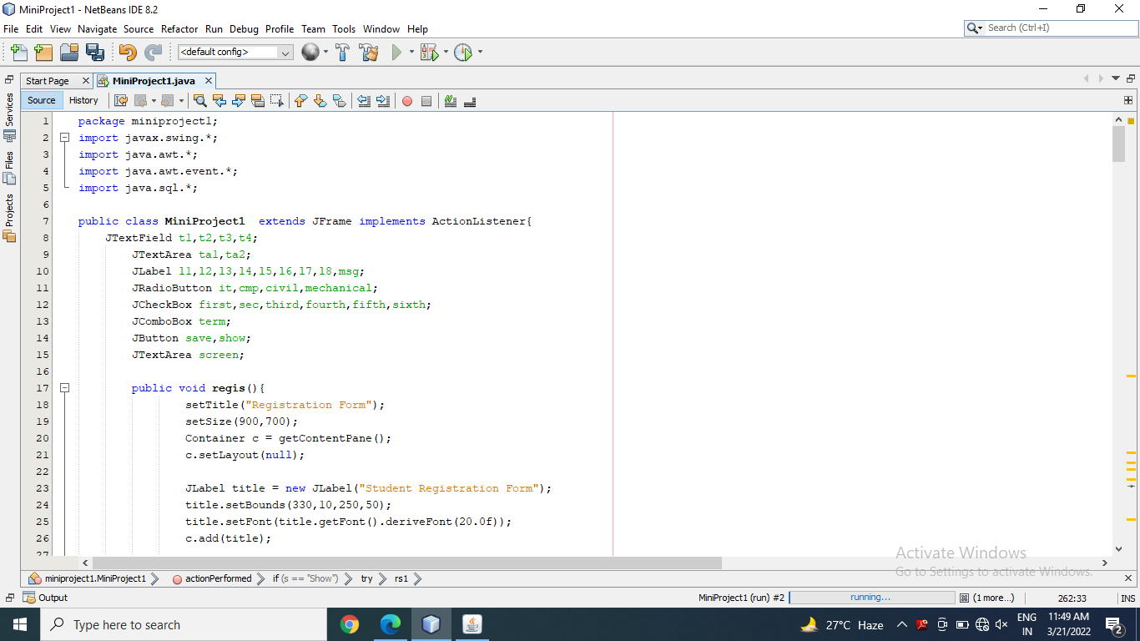

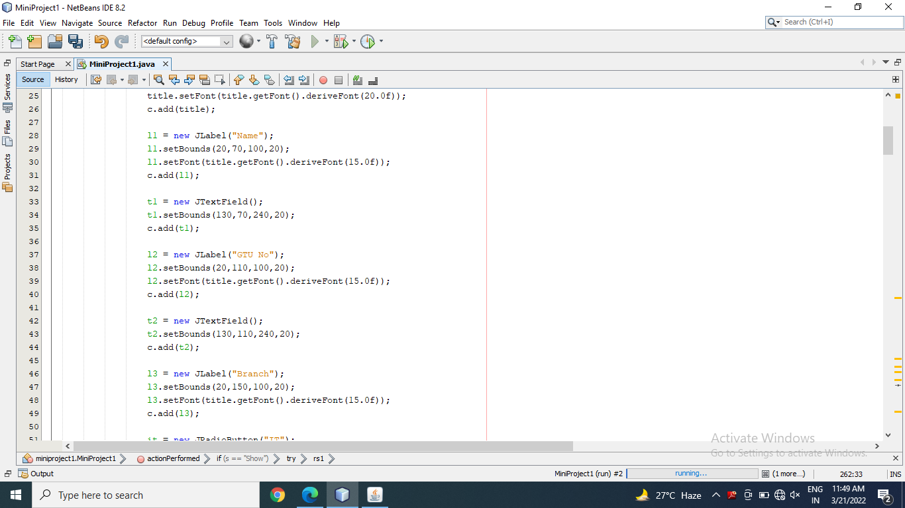

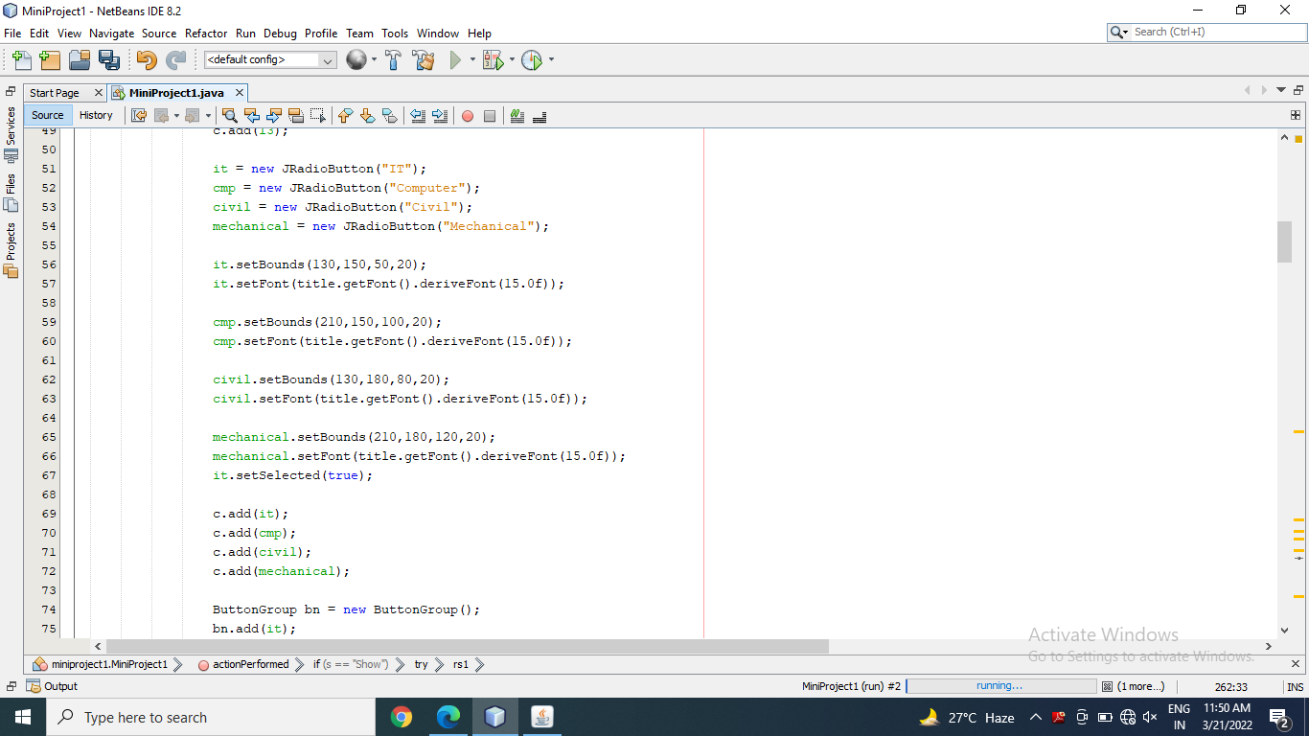

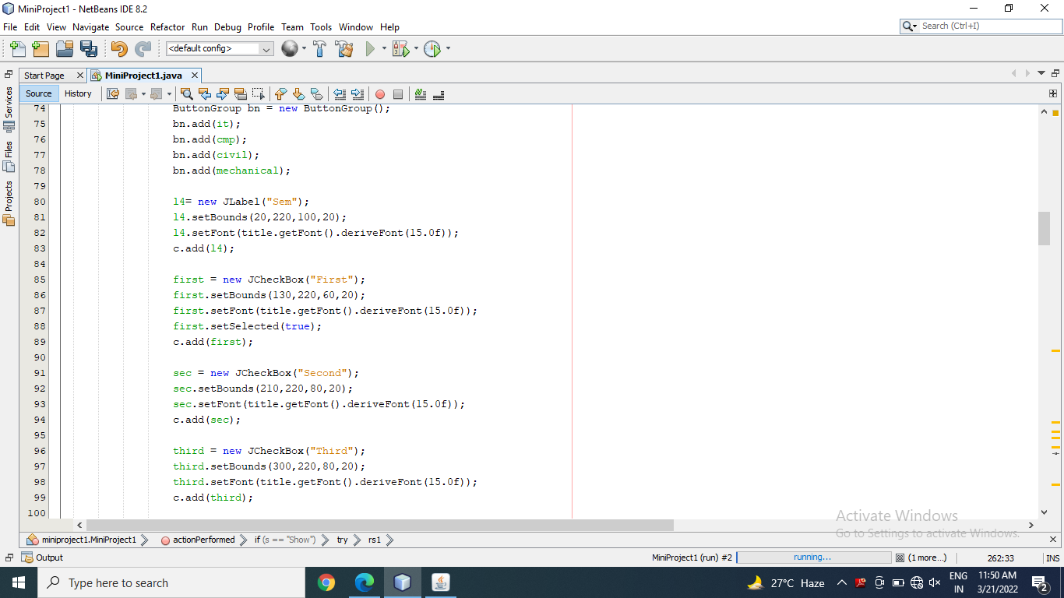

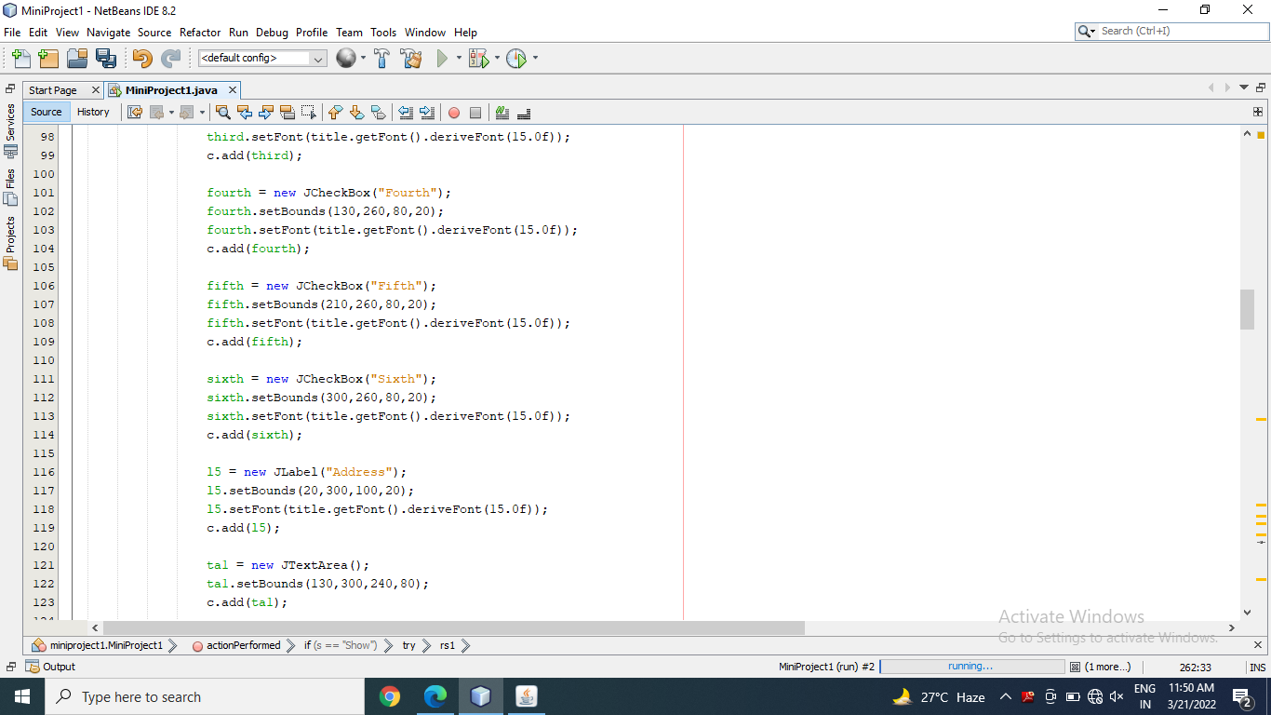

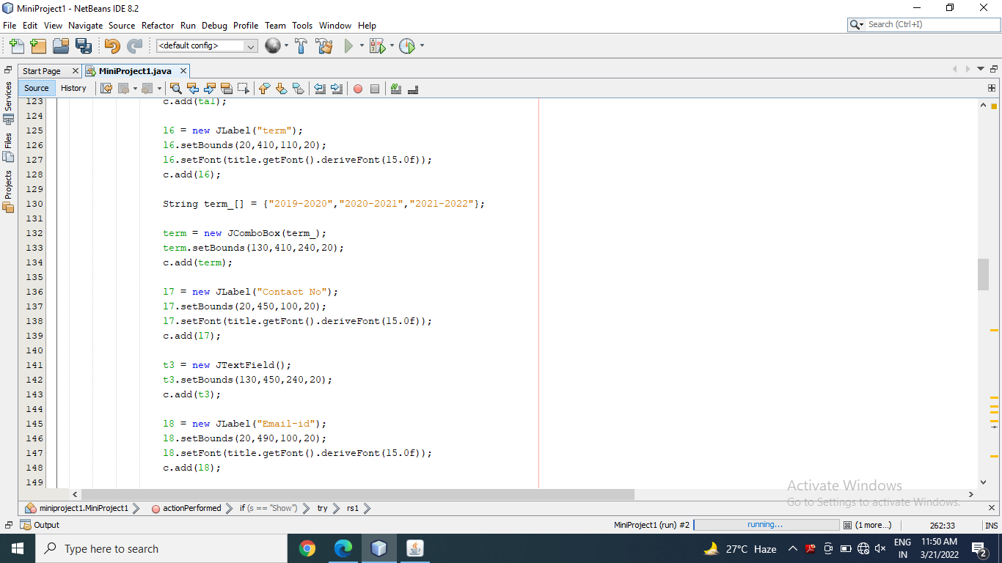

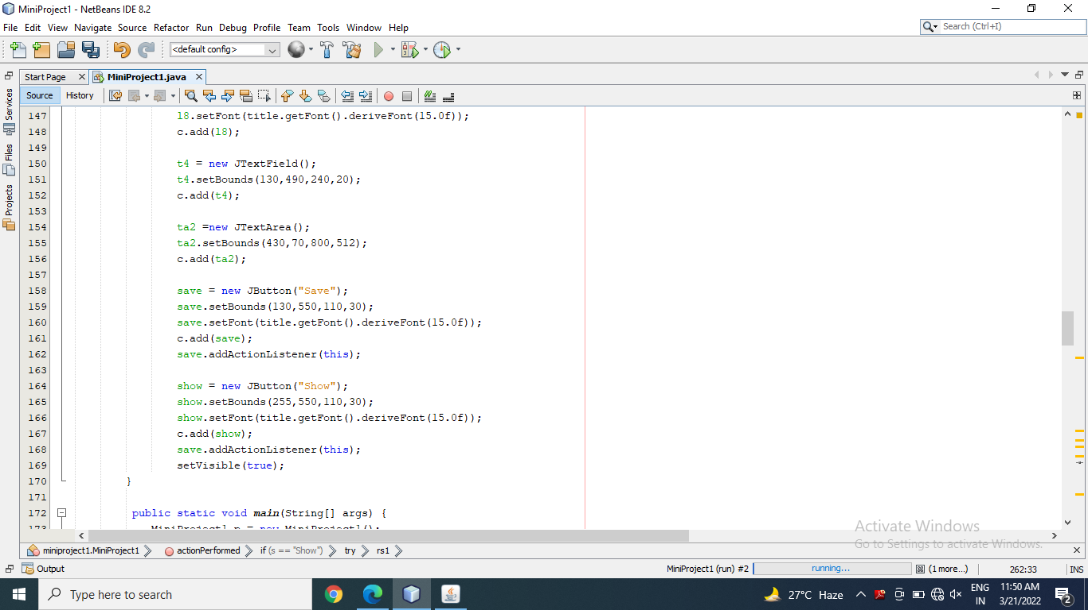

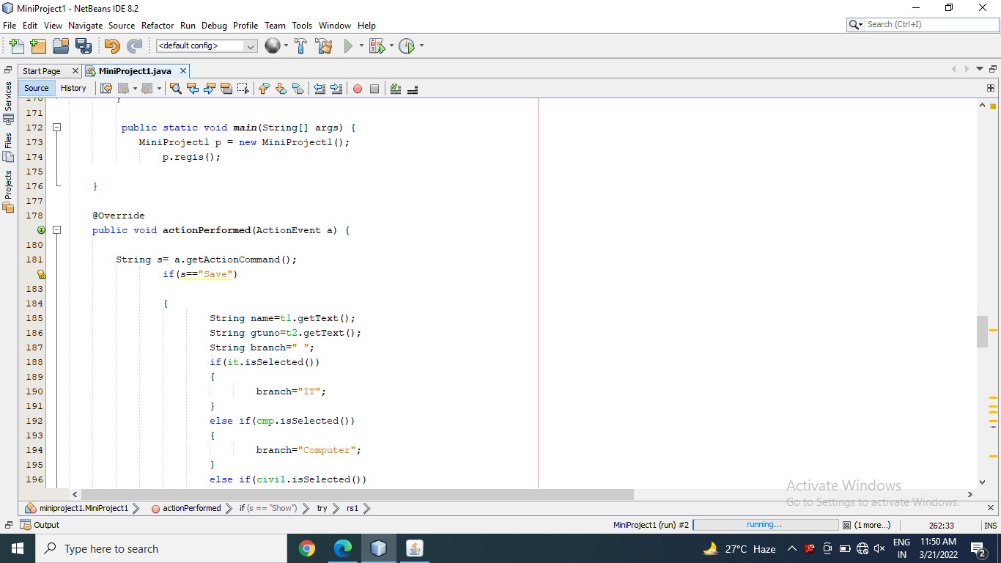

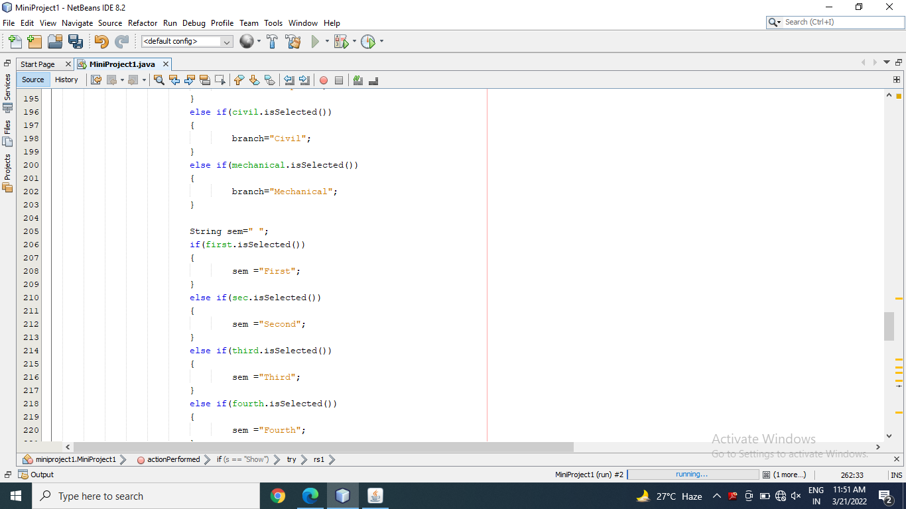

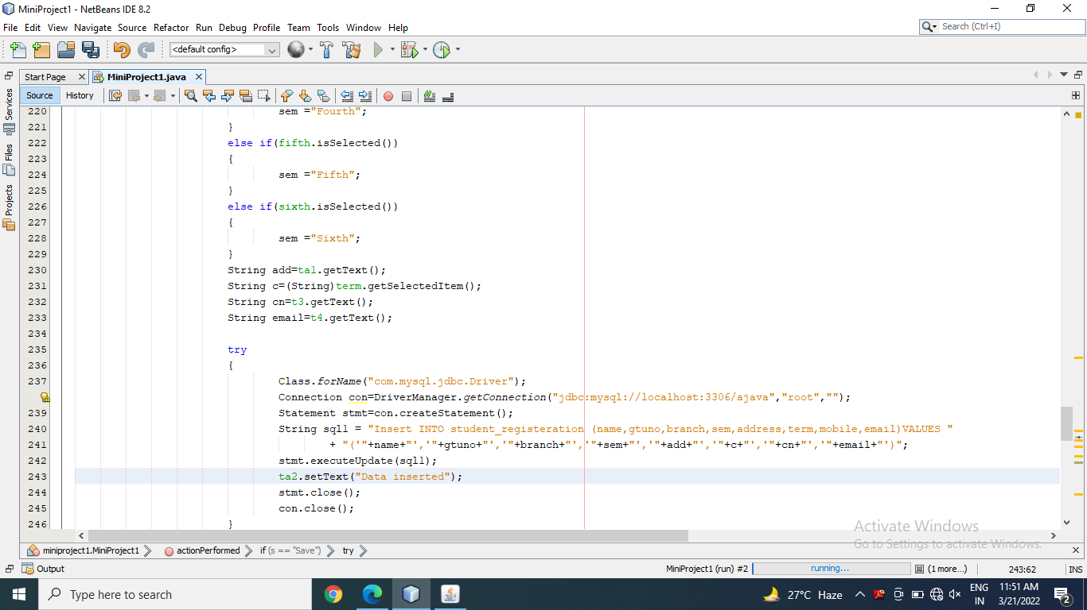

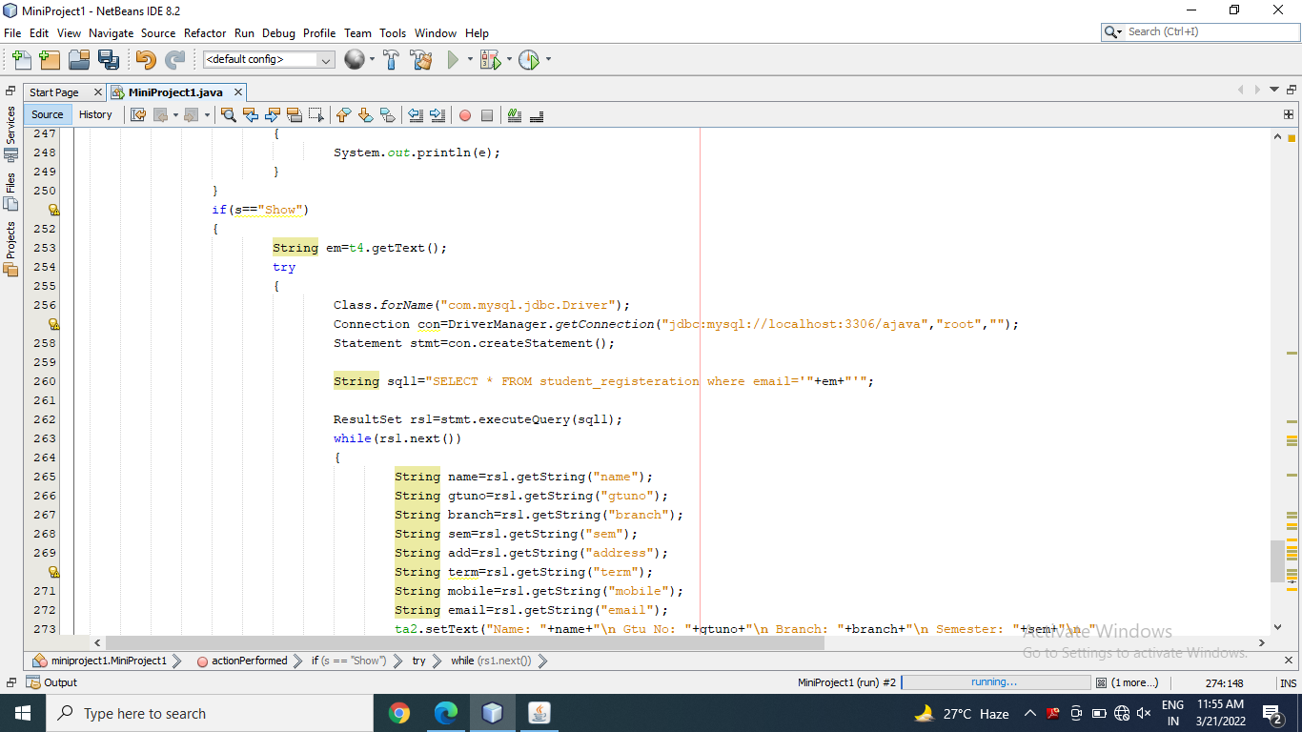

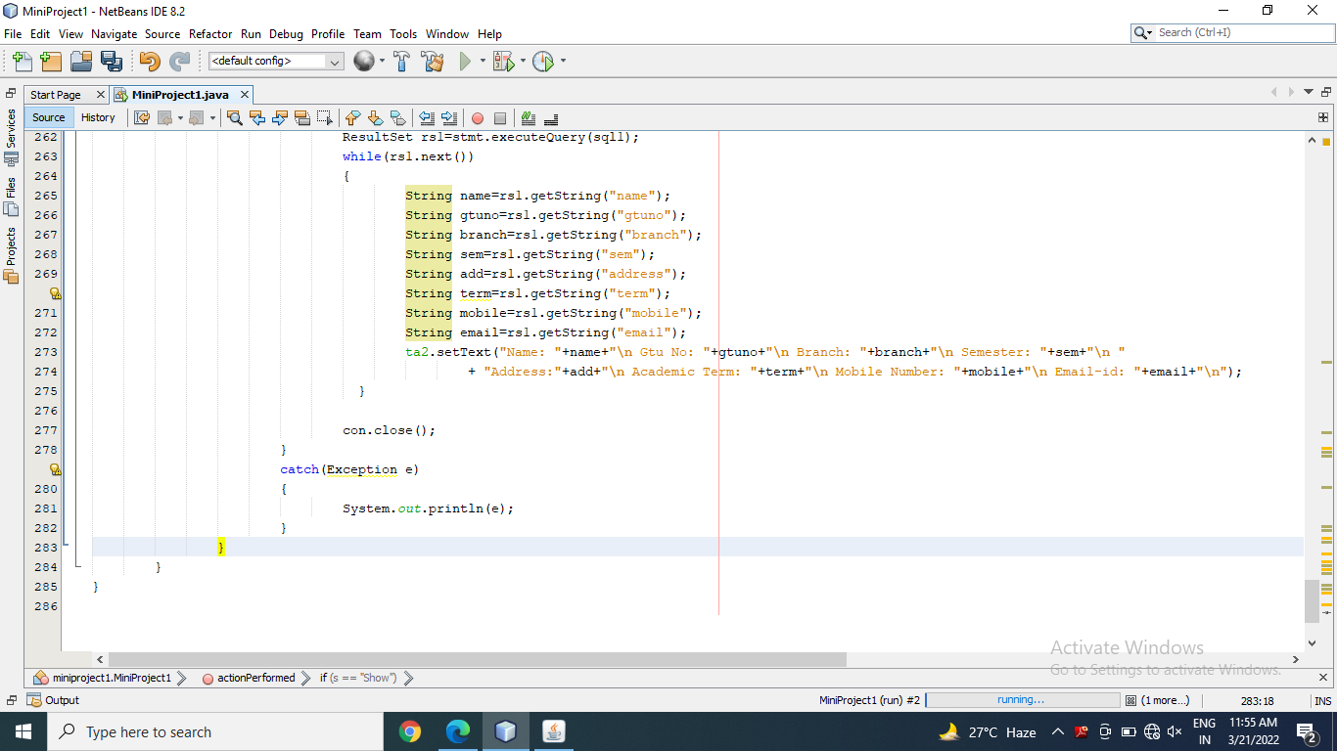

**OUTPUT:**

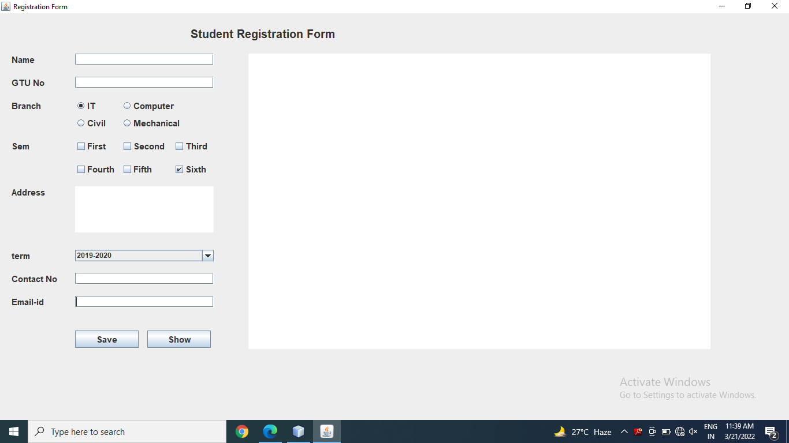

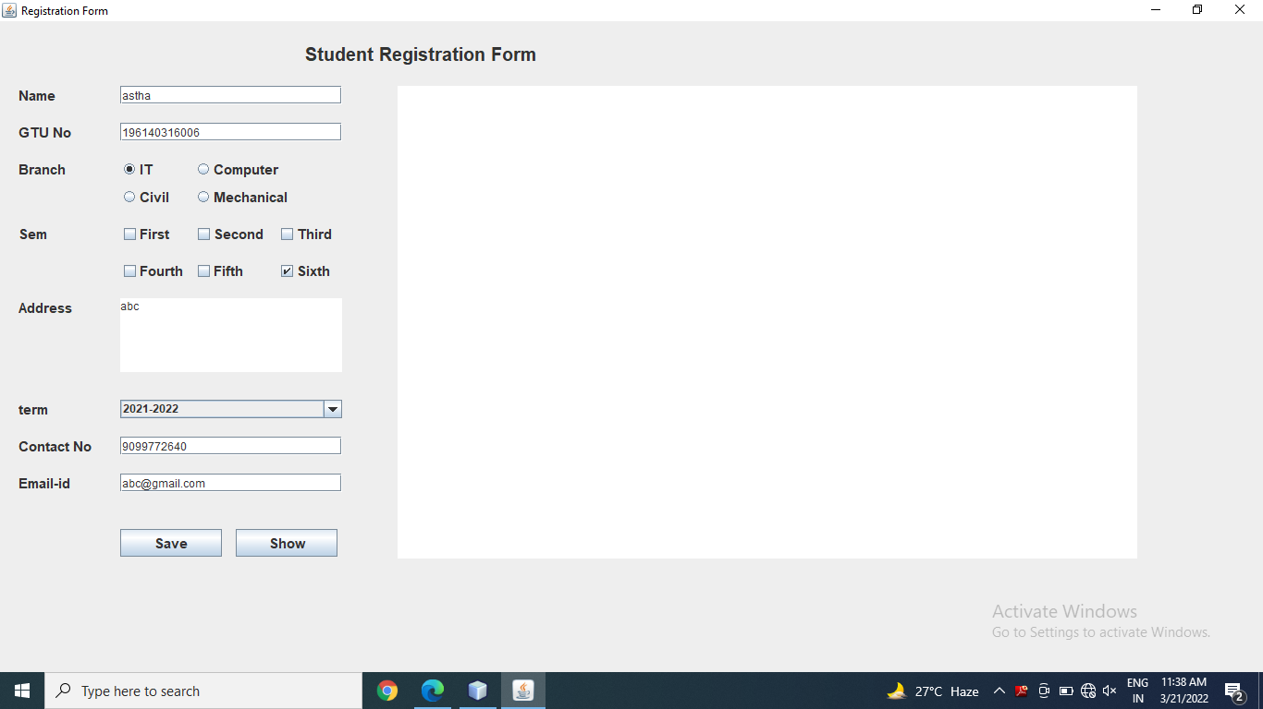

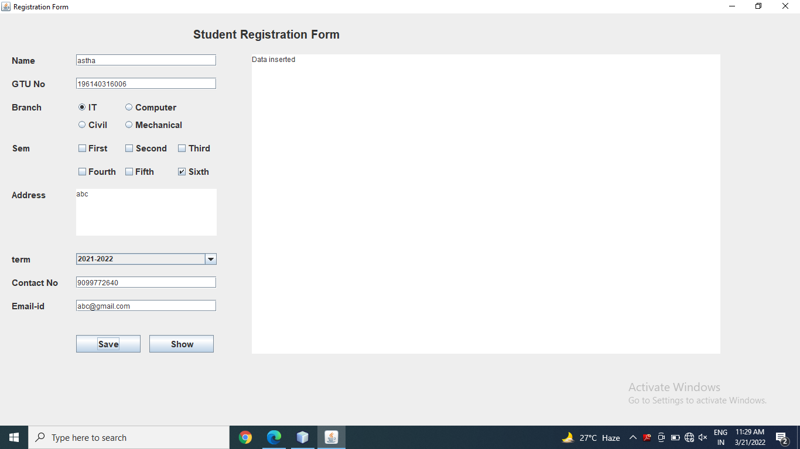

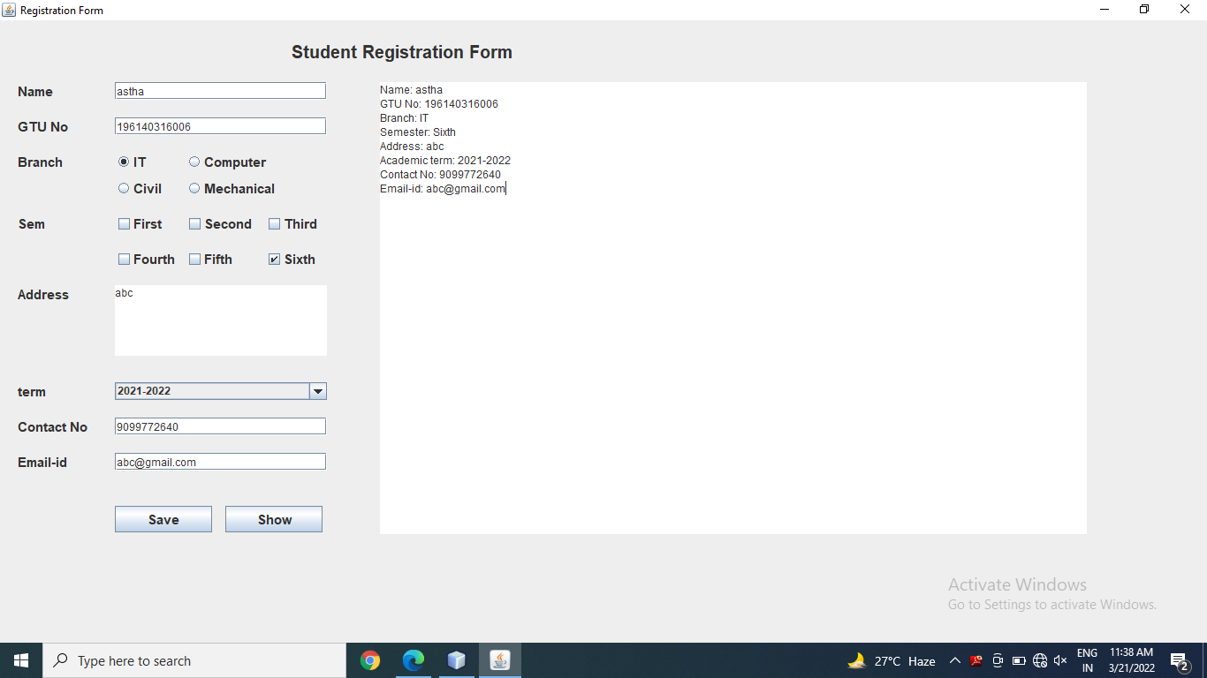

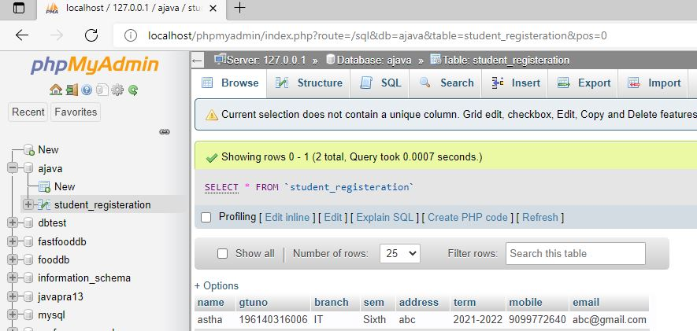

Thanks mam!!